It was cold across the TFX CWA this morning, but the RTMA/URMA appeared to have rejected most of the cold temperatures. There were widespread areas of -40F or colder in the Havre area…north to the border. The following shows the kml file output with a lot of red circles. Even at Havre, with a 12Z ob value of -36.49F, I could not find a temperature this cold in the analysis. It looks the the URMA analyzed the temperature at -25F. The Mud Lake site (D0217) had a temperature of -42, but it was rejected. The background was not even close.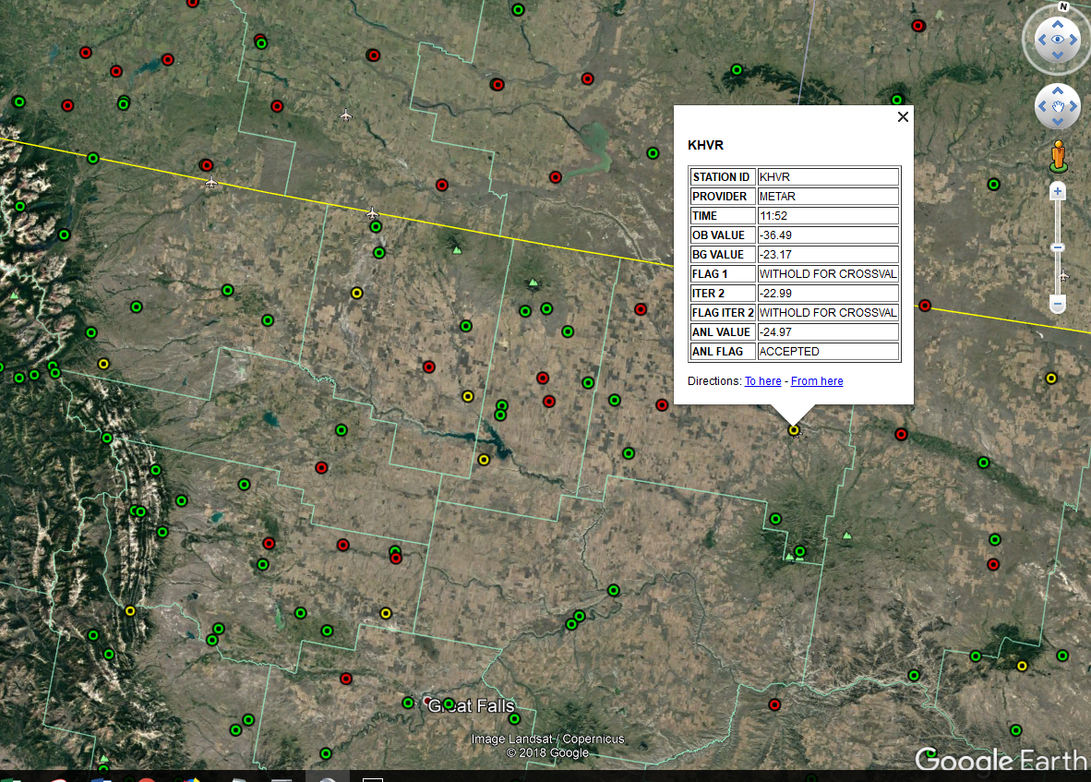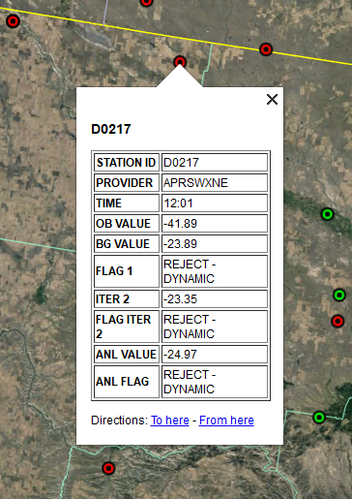

Here is the veritas output for 12Z, again showing the rejected obs. Its kind of hard to get the NBM to bias-correct to these cold temperatures when the analysis shows temperatures 15 to 20 degrees warmer than observations.

Also, I have never found the cursor readout too valuable when temperatures are colder than -20, when it reads all values at <= -20.

